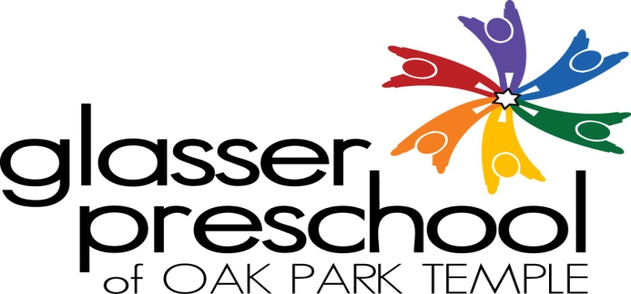

Winter 2017 Glasser Tots Class
(for toddlers)
Come join us on Friday mornings to celebrate Shabbat tot style!
We will play, sing, read, dance, and enjoy the company of other kids and parents/caregivers. We will end with traditional blessings for Challah and juice. Join the rest of Glasser Preschool in the Chapel for the weekly Shabbat celebration when Tots class is over.

Friday mornings from 9:30 to 10:30 AM
2/3/17 – 3/24/17
$75 for the Winter Session
Child must be accompanied by a parent or caregiver.

Our Tots Class is taught by Sari Haro.
Sari has been working on and off in Jewish education since the age of 12. She has dual degrees in elementary education and speech language pathology. Sari is happy to bring her expertise in child development to leading the Tots Class.

For more information, contact Director of Early Childhood Education,
Marci Sperling Flynn at (708) 386-3937 x15 or via email at glasserpreschool@oakparktemple.org.

Winter 2017 Glasser Tots Class Registration Form

Child’s Name: DOB:

Parents Names:

Address:

Telephone:

Email address:

Please return the bottom portion of this registration form with a check for $75 made payable to
“Glasser Preschool” to 1235 N. Harlem Avenue, Oak Park, IL 60302.

