Camp Bet Yeladim 2024

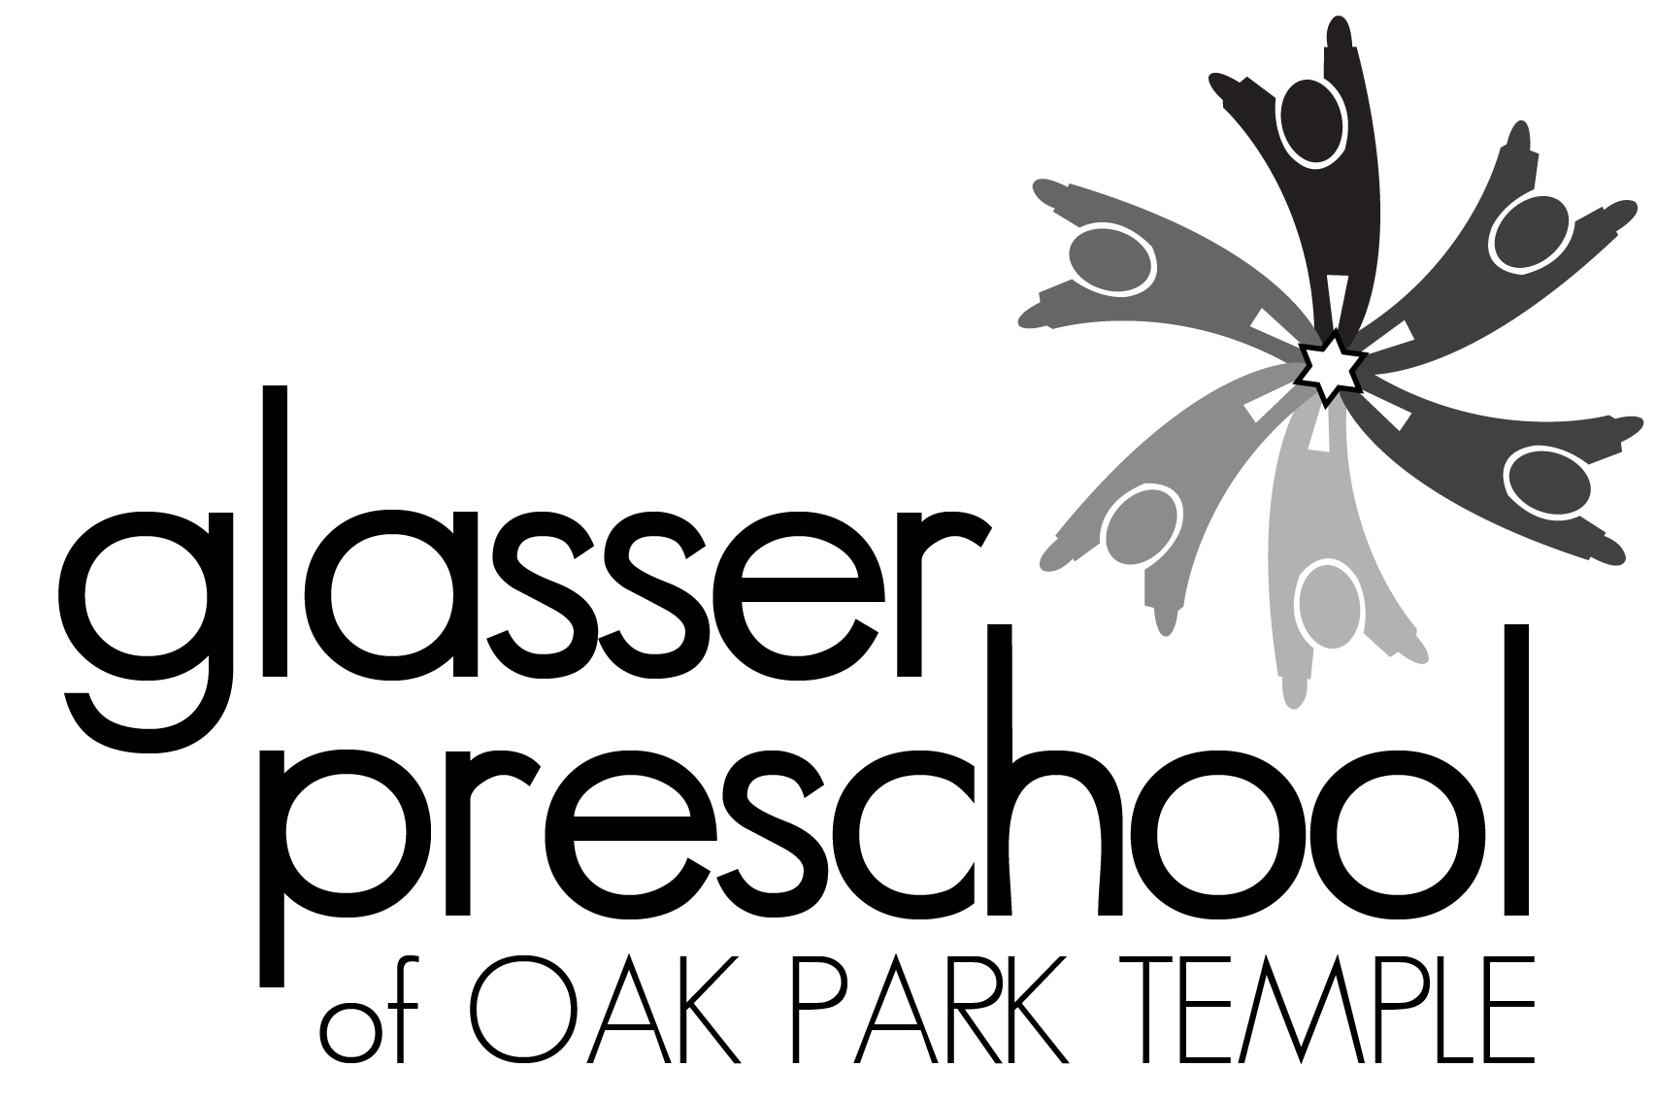
Young Children’s Summer Camp at Oak Park Temple
1235 N. Harlem Ave., Oak Park, IL 60302
708 386-3937 x215; glasserpreschool@oakparktemple.org; www.glasserpreschool.com
Marci Sperling Flynn, Director of Early Childhood Education

Camp Registration Dates:
Oak Park Temple Members: March 4-10 Glasser Preschool Families: March 11-17
Open to Community: March 18th

Camp Bet Yeladim offers children ages 3 to 6 an exciting and rewarding summer camp experience. Camp Bet Yeladim is also available for children who have completed Kindergarten and have not turned 7 yet. Children who were enrolled at Glasser Preschool during our 2023-2024 school year who will have not yet turned 3 by September 1st are welcome to attend Camp Bet Yeladim this summer too. This program provides fresh air and fun in a supervised camp conducted by trained adult staff. Camp is held outdoors on the lawn of Oak Park Temple’s backyard and in our air-conditioned classrooms. Our campers’ days consist of a combination of indoor and outdoor fun, water play, songs, art activities, stories, and more. There are weekly special theme days such as Pajama Day, Water Day, and Costume Day. Fridays we will celebrate Shabbat with special art activities, giving Tzedakah, Challah and grape juice at snack time, and Shabbat songs and stories together as a whole camp.

We will be offering four two-week sessions this summer with a break during 4th of July holiday week to allow for deep cleaning of the classrooms. Children can attend 3 days a week (Mon/Wed/Fri) or 5 days a week (Mon – Fri). You can choose for your child to attend camp for our traditional three-hour half-day program [8:30-11:30 AM] or our longer five-hour day [8:30 AM to 1:30 PM], which includes lunch provided by Glasser Preschool. Pursuant to DCFS regulations children may not bring their own lunch to Camp Bet Yeladim. We are offering four two-week sessions this summer. Sign up for one or more of our camp sessions! Session Aleph meets from June 3rd-14th (Closed June 12th for Shavuot), Session Bet meets from June 17th-28th (Closed June 19th for Juneteenth) ; we will be closed the week of July 1st for deep cleaning; Session Gimmel meets from July 8^{8th} – 19th; Session Dalet meets from July 22nd to August 2nd.

Fee & Payment Information:
- There is an additional $10 per child per session ($5 per week) supply fee
- There is an additional $20 per child per session ($10 per week) Non-Oak Park Temple member fee.
- A minimum of fifty per cent of the camp tuition is due at registration
- Payment can be made by cash, check made payable to “Glasser Preschool” or online
https://www.oakparktemple.org/form/CampBetYeladim2024Registration
- $50 per session is non-refundable until May 1, 2024. No refunds after May 1st.
- Early Bird Special: If you pay in full by April 1st – take 10% off your total camp tuition (not fees)!
- Payment in full is due by May 1, 2024.
- We reserve the right to cancel or consolidate groups due to insufficient enrollment. A full refund will be issued if a suitable alternative is not found for those children.
- Fees include camp t-shirt, water bottle, supply fee, snacks, and lunch (for 5-hour camp).

KEEP THIS PAGE FOR YOUR RECORDS

Camp Bet Yeladim 2024 Registration
Please complete both sides and submit a separate registration form for each child

Camper’s Name:_____________________________

Gender: DOB: ________ Age as of 9/1/24: _______

Address: ______________________________________________________

Preferred Phone Number: _______________________

E Mail: _______________________________________

Parent/Guardian Name(s):__________________________________________

Oak Park Temple Members? Yes ____ No ____

Please circle T shirt Size XS S M L
2-4 6-8 10-12 14-16

Please check all sessions which you would like your child to attend on the back of this page and transfer the information below:
 | Totals
Number of 2-week Sessions
Supply Fee
$10 per child per session
Non-Temple Member Fee
$20 per child per session
Camp Tuition
(tuition rates on back of form)
Total Enclosed (at least 50%)
(check, cash, or online payment)
If payment in full is received by April 1, 2024 – please deduct 10% of the camp tuition (not fees) | Early Bird Deduction  -
Remainder Due by 5/1/24
Return completed form to Glasser Preschool, 1235 N. Harlem Ave, Oak Park, IL 60302.
Payment can be made by cash, check made payable to “Glasser Preschool” or
online payment https://www.oakparktemple.org/form/CampBetYeladim2024Registration

OVER

Camper’s Name:

Please check applicable age group below:

My child attended Glasser Preschool for the 2023-2024 school year but will not be 3 by 9/1/24
My child will be 3 by 9/1/24

My child will be 4 by 9/1/24

My child will be 5 by 9/1/24

My child will be 6 by 9/1/24 but not 7
(includes current Kindergarten students)

Please check applicable camp sessions below:

 | Aleph  6/3 to 6/14  (closed 6/12) | Bet  6/17to 6/28  (closed 6/19) | Closed week July 1st | Gimmel  7/8– 7/19 | Dalet  7/22 – 8/2
Mon/Wed/Fri
8:30 AM – 11:30 AM
$195/session
Mon/Wed/Fri
8:30 AM – 1:30 PM
$325/session
Mon through Fri
8:30 AM – 11:30 AM
$320/session
Mon through Fri
8:30 AM – 1:30 PM
$510/session

Additional Camp Fees include: supply fee ($10 per 2-week session) and
Non-Oak Park Temple Member fee if applicable ($20 per 2-week session)

Please complete both sides of the registration form!

