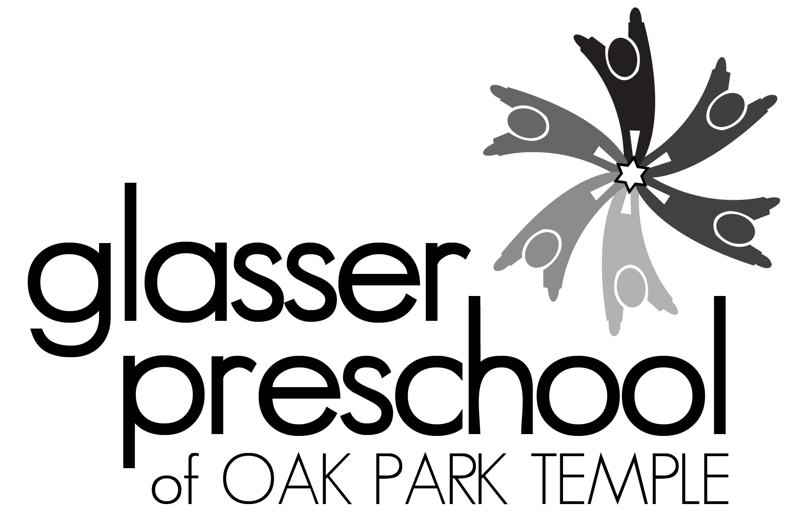

Camp Bet Yeladim 2017
Young Children’s Summer Camp at Oak Park Temple
1235 N. Harlem Ave., Oak Park, IL 60302
708 386-3937; glasserpreschool@oakparktemple.org; www.glasserpreschool.com
Marci Sperling Flynn, Director

Camp Registration Dates:
Oak Park Temple Members: February 27th – March 5th
Glasser Preschool Families: March 6th – 12th
Open to Community: March 13th

Camp Bet Yeladim offers children ages 3 to 6 an exciting and rewarding summer camp experience. This program provides fresh air and fun in a supervised camp conducted by trained adult staff. Camp is held outdoors on the lawn of Oak Park Temple’s backyard and in our air-conditioned classrooms. Our campers’ days consist of a combination of indoor and outdoor fun, water play, songs, art activities, stories, and field trips to the local parks. There are weekly special theme days such as Pajama Day, Water Day, and Costume Day. Fridays we will celebrate Shabbat with special art activities, giving Tzedakah, a visit to the Chapel for Shabbat songs, and Challah at snack time.

You can choose to attend camp for our traditional three-hour half-day program [8:45 AM to 11:45 AM] or our longer five-hour day [8:45 AM to 1:45 PM], which includes lunch provided by Gourmet Gorilla. Pursuant to DCFS regulations children may not bring their own lunch to Camp Bet Yeladim. Early drop off option at 8 AM with supervision by Oak Park Temple teens will be available for a fee for those who need it.

We are excited to offer eight fun filled weeks of camp this summer!!! Sign up for one or more of our two-week sessions! Session Aleph: 6/5 – 6/16; Session Bet: 6/19 – 6/30; Session Gimmel: 7/3 – 7/14 [no camp 7/4];. Session Dalet: 7/17 -7/28.

Payment Information:
- Fifty per cent of the camp tuition is due at registration
- $25 per session is non refundable until May 1, 2017. No refunds after May 1st.
- Oak Park Temple members pay a lower rate. There is an additional $20 fee per child per session for non-temple members. [Temple member rate/non Temple member rate]
- Payment in full is due by May 1, 2017.
- Early Bird Special: If you pay in full by April 1st – take 10% off your total camp tuition!
- We reserve the right to cancel or consolidate groups due to insufficient enrollment. A full refund will be issued if a suitable alternative is not found for those children.
- Fees include camp t-shirt, water bottle, supply fee, snacks, and lunch (for 5 hour camp).

Camp Bet Yeladim 2017 Registration
Please complete both sides and submit a separate registration form for each child

Camper’s Name:_____________________________

Sex: M___ F___ DOB: ________ Age as of 9/1/17: _______

Address: ______________________________________________________

Home Phone: _______________________ Cell Phone:____________________

E Mail: _______________________________________

Parents/Guardians:__________________________________________

Oak Park Temple Members? Yes ____ No ____

Please circle T shirt Size 2/4 6/8 10/12

Please check all sessions which you would like your child to attend on the back of this page and transfer the information below:

Total Number of Sessions
Total Camp Tuition
[Oak Park Temple members pay the lower tuition rate OPT/Non OPT]
Total Enclosed (at least 50%)
Checks payable to “Glasser Preschool”
If payment in full is received by April 1, 2017 – please deduct 10% of the total camp tuition | Early Bird Deduction by 4/1  -
Remainder Due by 5/1/17

Please indicate if you need early drop off supervision beginning at 8 AM. Yes __ No ___

Return completed forms with checks made payable to “Glasser Preschool” to 1235 N. Harlem Ave, Oak Park, IL 60302.
Camper’s Name: DOB:

Please complete both sides of the registration form!

Oak Park Temple members pay lower rate  OPT/non OPT | Session Aleph  June 5 – June 16 | Session Bet  June 19 – June 30 | Session Gimmel  July 3 – July 14 | Session Dalet  July 17 – July 28
3 years old by 9/1/17 (or enrolled in our 3 year old Lions program for Fall 2017)
Mon/Wed/Fri
8:45 AM – 11:45 AM
$150/$170 session
Mon/Wed/Fri
8:45 AM – 1:45 PM
$270/$290 session
Mon through Fri
8:45 AM – 11:45 AM
$260/$280 session
Mon through Fri
8:45 AM – 1:45 PM
$440/$460 session
4 years old by 9/1/17
Mon/Wed/Fri
8:45 AM – 11:45 AM
$150/$170 session
Mon/Wed/Fri
8:45 AM – 1:45 PM
$270/$290 session
Mon through Fri
8:45 AM – 11:45 AM
$260/$280 session
Mon through Fri
8:45 AM – 1:45 PM
$440/$460 session
5 years old by 9/1/17
Mon/Wed/Fri
8:45 AM – 11:45 AM
$150/$170 session
Mon/Wed/Fri
8:45 AM – 1:45 PM
$270/$290 session
Mon through Fri
8:45 AM – 11:45 AM
$260/$280 session
Mon through Fri
8:45 AM – 1:45 PM
$440/$460 session
6 years old by 9/1/17
Mon/Wed/Fri
8:45 AM – 11:45 AM
$150/$170 session
Mon/Wed/Fri
8:45 AM – 1:45 PM
$270/$290 session
Mon through Fri
8:45 AM – 11:45 AM
$260/$280 session
Mon through Fri
8:45 AM – 1:45 PM
$440/$460 session

