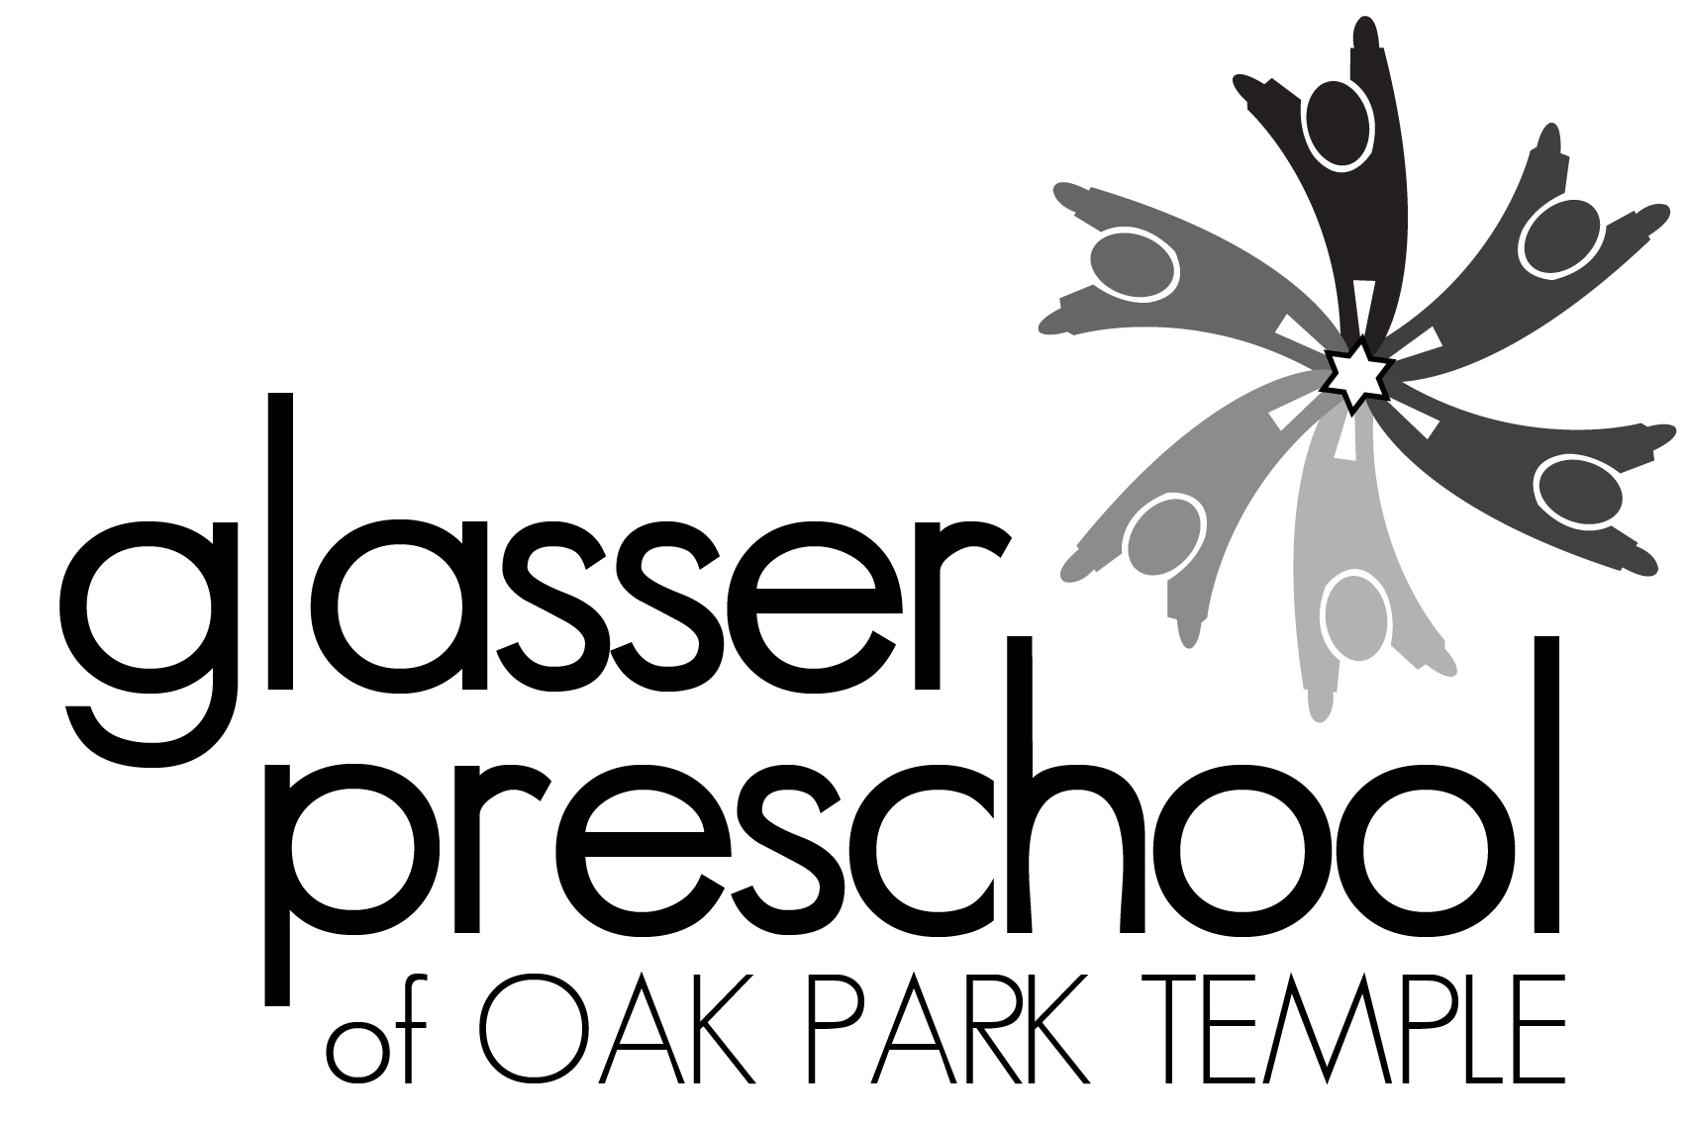

Camp Bet Yeladim 2020
Young Children’s Summer Camp at Oak Park Temple
1235 N. Harlem Ave., Oak Park, IL 60302
708 386-3937; glasserpreschool@oakparktemple.org; www.glasserpreschool.com
Marci Sperling Flynn, Director of Early Childhood Education

Camp Registration Dates:
Oak Park Temple Members: March 2nd – 8th
Glasser Preschool Families: March 9th – 15th
Open to Community: March 16th

Camp Bet Yeladim offers children ages 3 to 6 an exciting and rewarding summer camp experience. Camp Bet Yeladim is also available for children who have completed Kindergarten and have not turned 7 yet. Children who were enrolled at Glasser Preschool during our 2019-2020 school year who have not yet turned 3 are welcome to attend Camp Bet Yeladim this summer too. This program provides fresh air and fun in a supervised camp conducted by trained adult staff. Camp is held outdoors on the lawn of Oak Park Temple’s backyard and in our air-conditioned classrooms. Our campers’ days consist of a combination of indoor and outdoor fun, water play, songs, art activities, stories, and more. There are weekly special theme days such as Pajama Day, Water Day, and Costume Day. Fridays we will celebrate Shabbat with special art activities, giving Tzedakah, a visit to the Chapel for Shabbat songs, and Challah at snack time.

You can choose to attend camp for our traditional three-hour half-day program [8:30-11:30 AM] or our longer five-hour day [8:30 AM to 1:30 PM], which includes lunch provided by Gourmet Gorilla. Pursuant to DCFS regulations children may not bring their own lunch to Camp Bet Yeladim. Early drop off option at 8 AM will be available for a fee for those who need it. We are excited to offer nine fun filled weeks of camp this summer!!! Sign up for one or more of our camp sessions! Session Aleph meets only for a one week session. The remainder of the camp sessions (Bet through Hay) meet for two weeks. Session Aleph: 6/1 – 6/5 (one week); Session Bet: 6/8 -6/19; Session Gimmel 6/22 – 7/2 (No Camp 7/3); Session Dalet: 7/6 -7/17; Session Hay: 7/20-7/31.

Payment Information:
- Fifty per cent of the camp tuition is due at registration
- $25 per session is non refundable until May 1, 2020. No refunds after May 1st.
- Oak Park Temple members pay a lower rate. There is an additional $20 fee per child per session for non-temple members. [Temple member rate/non Temple member rate]
- Payment in full is due by May 1, 2020.
- Early Bird Special: If you pay in full by April 1st – take 10% off your total camp tuition!
- We reserve the right to cancel or consolidate groups due to insufficient enrollment. A full refund will be issued if a suitable alternative is not found for those children.
- Fees include camp t-shirt, water bottle, supply fee, snacks, and lunch (for 5 hour camp).

KEEP THIS PAGE FOR YOUR RECORDS

Camp Bet Yeladim 2020 Registration
Please complete both sides and submit a separate registration form for each child

Camper’s Name:_____________________________

Gender: DOB: ________ Age as of 9/1/20: _______

Address: ______________________________________________________

Home Phone: _______________________ Cell Phone:____________________

E Mail: _______________________________________

Parents/Guardians:__________________________________________

Oak Park Temple Members? Yes ____ No ____

Please circle T shirt Size XS S M L
2-4 6-8 10-12 14-16

Please check all sessions which you would like your child to attend on the back of this page and transfer the information below:

Total Number of Sessions
Total Camp Tuition
[Oak Park Temple members pay the lower tuition rate OPT/Non OPT]
Total Enclosed (at least 50%)
Checks payable to “Glasser Preschool”
If payment in full is received by April 1, 2020 – please deduct 10% of the total camp tuition | Early Bird Deduction by 4/1  -
Remainder Due by 5/1/20

Please indicate if you need early drop off supervision beginning at 8 AM. Yes __ No ___

Return completed forms with checks made payable to “Glasser Preschool” to 1235 N. Harlem Ave, Oak Park, IL 60302.

OVER

Camper’s Name: DOB:

Oak Park Temple members pay lower rate  OPT/non OPT | Session Aleph  *1 week only*  6/1-6/5  *Note different pricing for this one week session* | Session Bet  6/8-6/19 | Session Gimmel  6/22-7/2  No camp 7/3 | Session Dalet  7/6-7/17 | Session Hay  7/20-7/31
3 years old by 9/1/20
(or were enrolled in our 2 year old program during the 2019-2020 school year)
Mon/Wed/Fri  8:30 AM – 11:30 AM  $175/$195  Sessions Bet-Hay | *$85/$95*
Mon/Wed/Fri  8:30 AM – 1:30 PM  $295/$315  Sessions Bet-Hay | *$145/$155*
Mon through Fri  8:30 AM – 11:30 AM  $285/$305  Sessions Bet-Hay | *$140/$150*
Mon through Fri  8:30 AM – 1:30 PM  $465/$485  Sessions Bet-Hay | *$230/$240*
4 years old by 9/1/20
Mon/Wed/Fri  8:30 AM – 11:30 AM  $175/$195  Sessions Bet-Hay | *$85/$95*
Mon/Wed/Fri  8:30 AM – 1:30 PM  $295/$315  Sessions Bet-Hay | *$145/$155*
Mon through Fri  8:30 AM – 11:30 AM  $285/$305  Sessions Bet-Hay | *$140/$150*
Mon through Fri  8:30 AM – 1:30 PM  $465/$485  Sessions Bet-Hay | *$230/$240*
5 or 6 years old by 9/1/20
(Including children who completed Kindergarten in the 2019-2020 school year)
Mon/Wed/Fri  8:30 AM – 11:30 AM  $175/$195  Sessions Bet-Hay | *$85/$95*
Mon/Wed/Fri  8:30 AM – 1:30 PM  $295/$315  Sessions Bet-Hay | *$145/$155*
Mon through Fri  8:30 AM – 11:30 AM  $285/$305  Sessions Bet-Hay | *$140/$150*
Mon through Fri  8:30 AM – 1:30 PM  $465/$485  Sessions Bet-Hay | *$230/$240*

Please complete both sides of the registration form!

